

**END OF TERM ONE EXAMINATIONS 2023**

**BABY CLASS**

**SOCIAL DEVELOPMENT**

NAME_______________________________

1. **Colour your father and mother**.

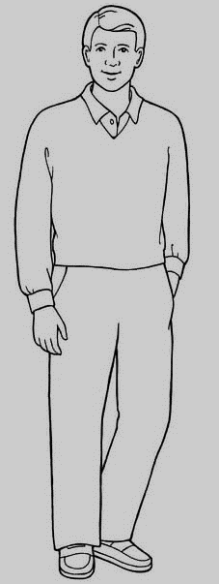

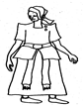

1. **Trace your father**.

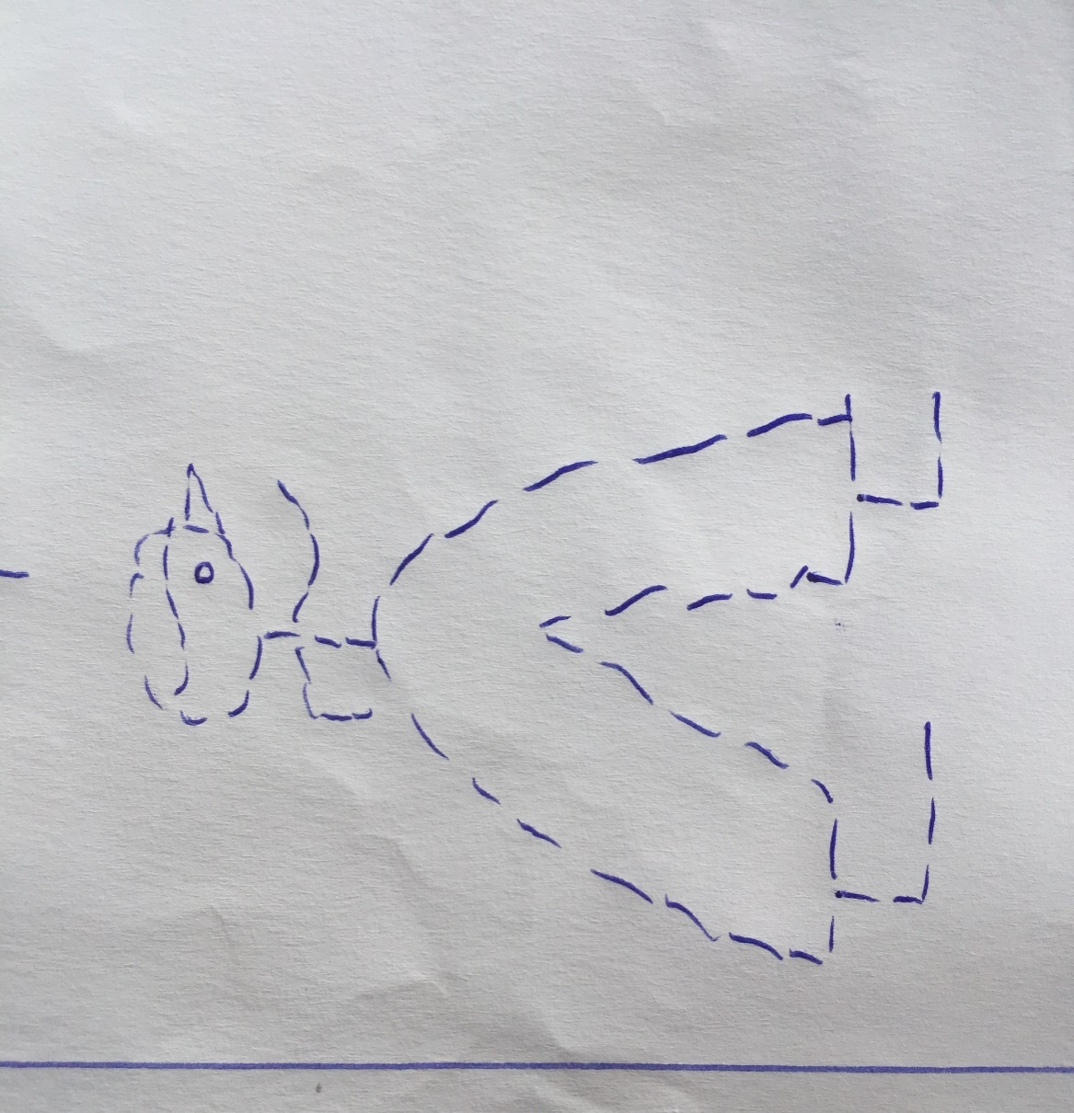

1. **Match the same**.









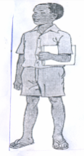







1. Trace your mother.

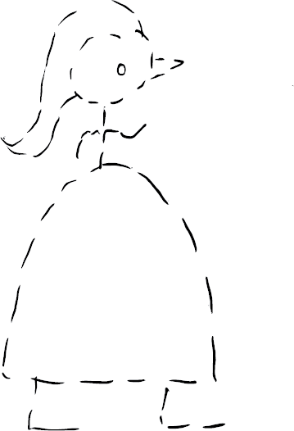

1. **Oral questions**.
2. Good morning?
3. What is your name?
4. How many days make a week?
5. In which class are you?
6. What is the name of your teacher?